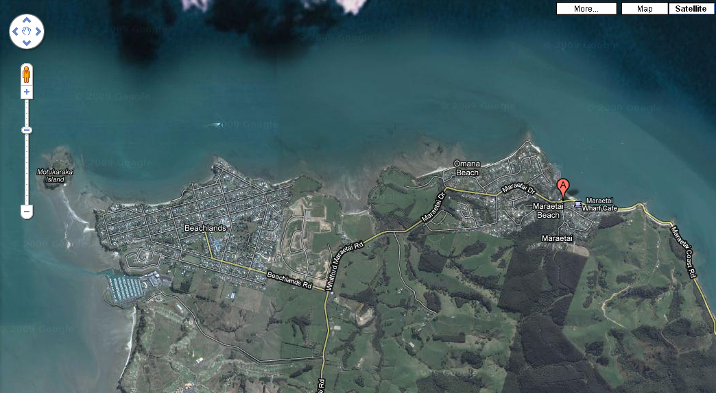

Start & Finish
Pine Harbour Marina
BEACHLANDS

Bus Return Finish
Maraetai Park
MARAETAI

= Pit Stop

